**Heuristic Review of the “INFLO” Web Application**

**Summary**

The Second Mockathon UX team was tasked to perform an evaluation of the “INFLO” website on 21 March 2015. This report summarizes the high level findings of this evaluation.

Two primary concerns were exposed. Complicated language was used throughout the application that would confuse the user and discourage use. A lack of simplified instruction was not available creating a unclear landing page. Detailed descriptions of all usability issues exposed during this evaluation are included in the following sections.

**Assessment Method**

Heuristic evaluation is an assessment method which rates software applications and interfaces based on compliance with basic human factors principles of design. For this evaluation, four areas were considered.

1. Perceiving and Evaluating the System
2. Developing and Executing Action Sequences
3. Context and Relations
4. Specific Interface and System Issues

**Overall Impressions**

From the INFLO homepage, users can easily search for a county to view comparative data from. However no information on what data will be retrieved is available. There is no example data available and no description of the pages purpose. The page focus should be set on the input box on page load.

The INFLO dashboard shows the county and associated state that was searched for. It gives an overall score that is not self-explanatory. The score percentage should be in comparison to all other counties to show context. Four tiles showing Water Quality, Air Quality, People, and Travel Safety are showing county data. This data does not provide context and displays a percentage that is not associated with a positive or negative result. Results should show percentages lower or higher than all counties data.

**INFLO Home Screen (Wireframe):**

* Logo centered at top (alt text for logo image)
* Search centered under logo (alt text for search button if image used)
* Search includes example input “Fairfax, VA”
* Focus is on search on page load
* Tagline below search box
  + “How much do you know about where you live?”
* Search informative infographic
  + “Search for a County” “View the Score” “Explore the Details”
  + Three screenshots showing steps. (alt text explaining images)
  + Arrows showing flow. (alt text “Arrow pointing right”)

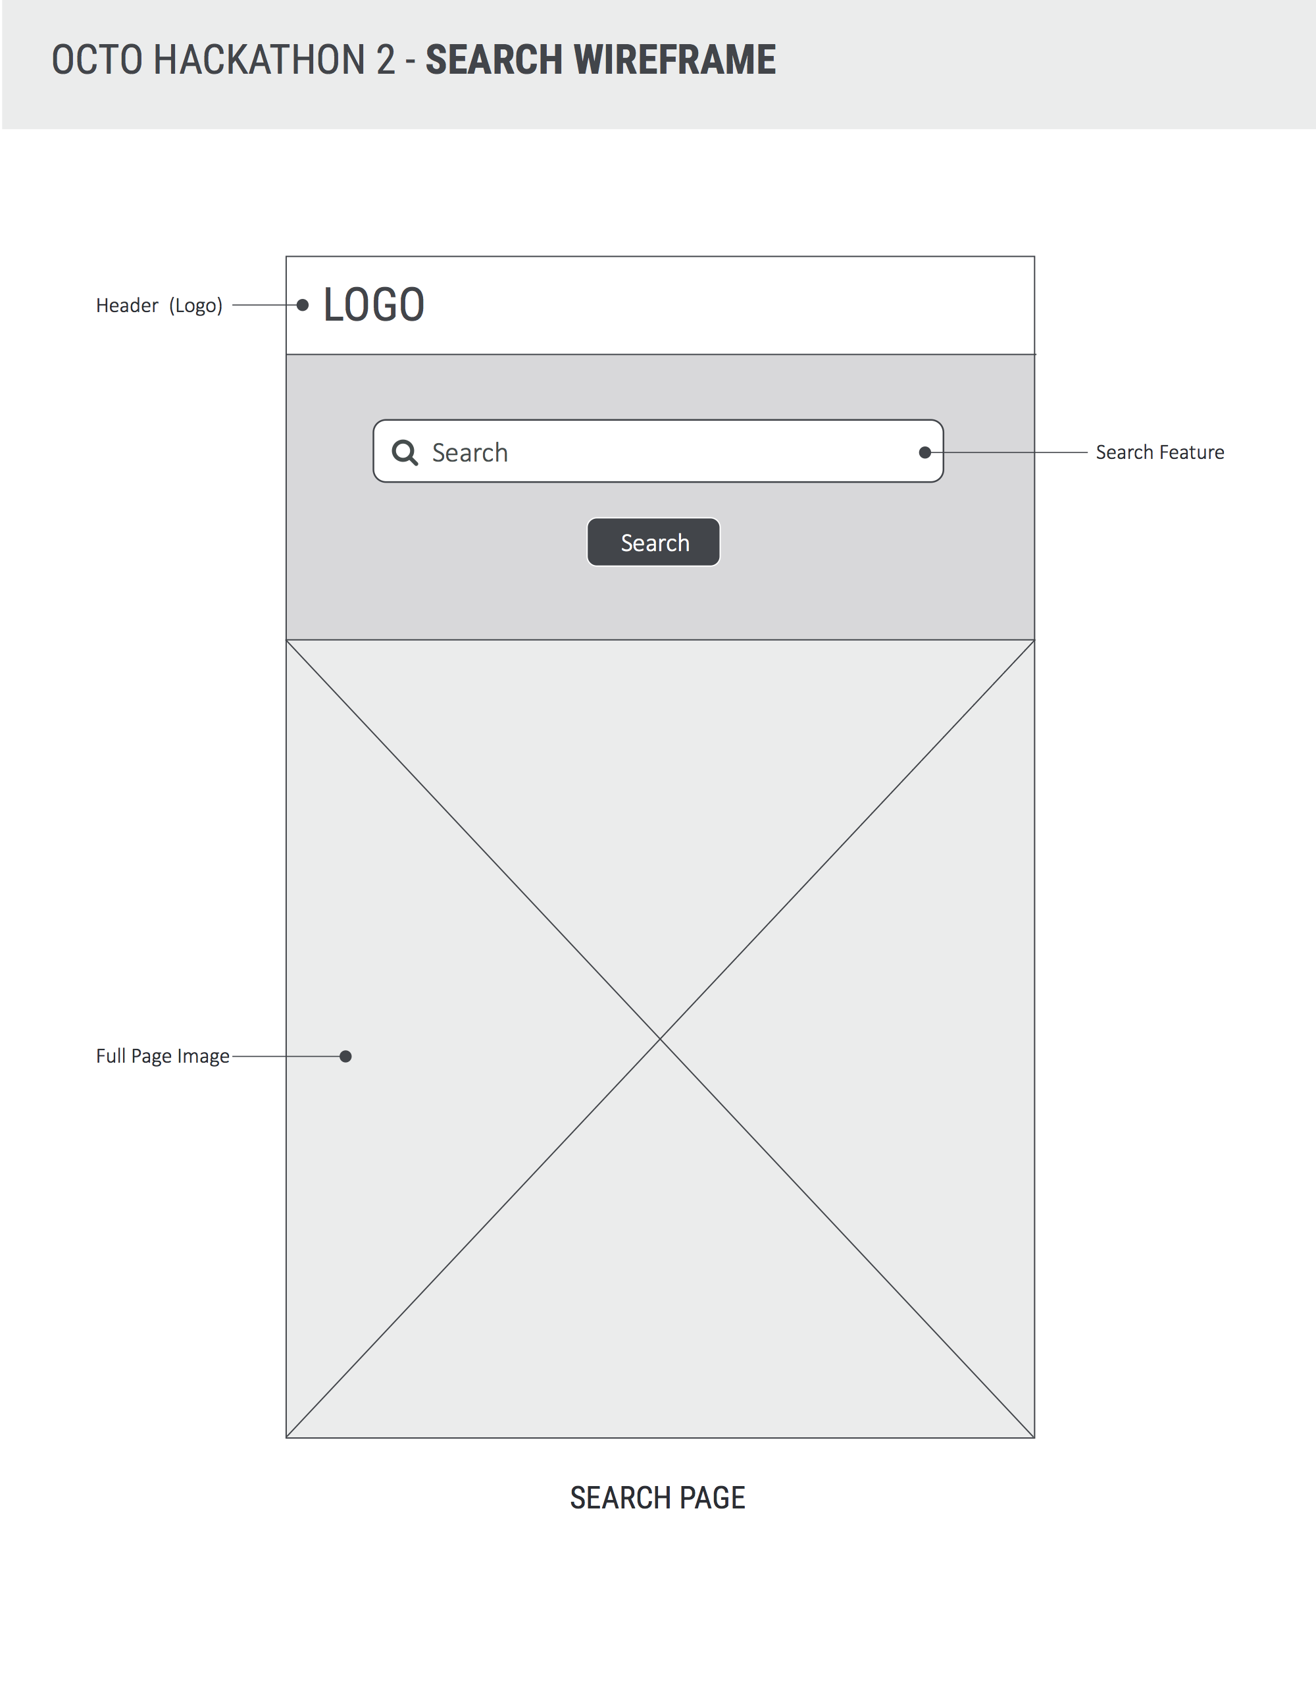

**INFLO Dashboard Screen (Wireframe):**

* Logo centered at top (alt text for logo image; link back to home page)
* Search centered under logo (alt text for search button if image used)
* Search includes example input “Fairfax, VA”
* Focus is on search on page load
* Tagline below search box
  + “How much do you now about where you live?”
* County name and associated state is shown under search.
  + County name is larger than state showing data is pertaining to county only.
  + Large score is shown on right with percentage.
* Four tiles are displayed below county name and score
  + “People”, “Travel Safety”, “Air Quality”, “Water Quality”

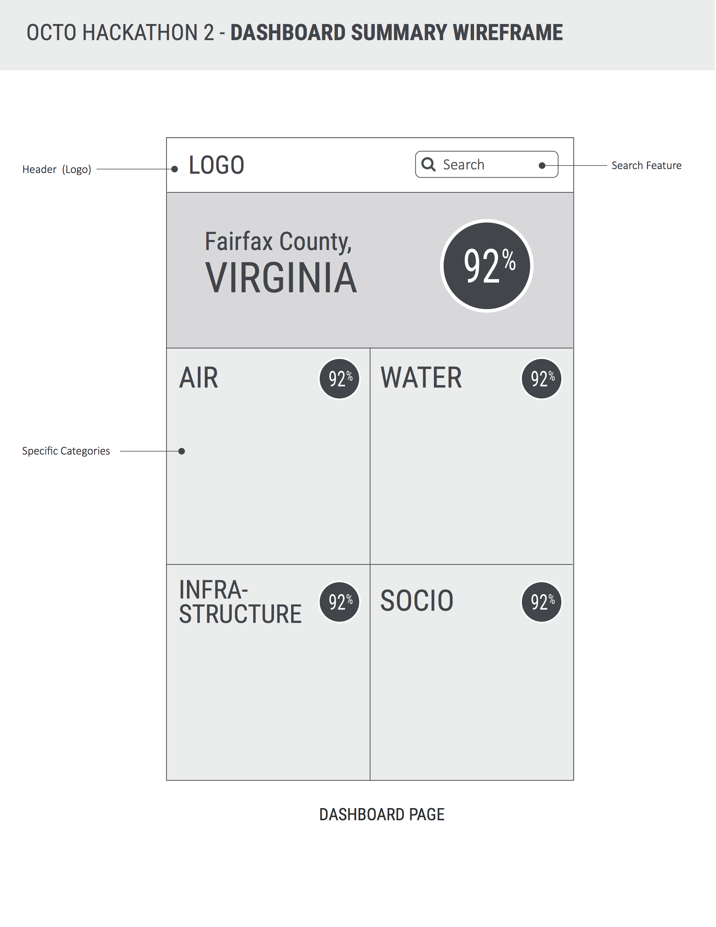**INFLO Tiles (Wireframe):**

* “People”, “Travel Safety”, “Air Quality”, “Water Quality”
  + People
    - Median Income
    - Percentage of Unemployed
    - Rate of Violent Crime
  + Travel Safety
    - Highway Roads
    - Streets
    - Traffic Fatality
  + Air Quality
    - Nitrogen Dioxide (NO2)
    - Sulfur Dioxide (SO2)
    - Carbon Monoxide (NO2)
  + Water Quality
    - Percentage of county drought
    - Percentage of Mercury
    - Percentage of Arsenic
* *Show more info about data point on select?*
* *Small text “Levels based on blab bla bla Data source”?*

**Any percentage under 50% will display as the difference from the mean.**

**30% Higher = 70% Lower**

**Conclusion**

A simple and informative search is necessary for an effective user experience. Clear direction and understandable terminology is needed. Accessibility should always be considered to allow for a diverse base of users.

Data should be presented in a way that is obvious to the user. All data points should relate to the county searched as well as it’s place among other counties.

**Modifications Made**

Design was improved to show Logo, Search, and Tagline on top center and remains throughout the app home page as well as dashboard.

Search button was incorporated into search box.

Search infographic showing a three-step process was added to home screen.

Tile names were updated to “People”, “Travel Safety”, “Air Quality”, “Water Quality”.

Data Sources were added to tiles.

**INFLO Home Screen (1rst Release):**

1. Search Text
   * Search should not be Cap sensitive and spaces between county and state code should not be used to determine search results.
2. Infographic
   * Graphics should not include rasterized text.
   * Graphic size should be decreased to include smaller resolutions and reduce complexity
   * Alt text is needed for accessibility
3. Search Icon/Button
   * Alt text is needed for accessibility

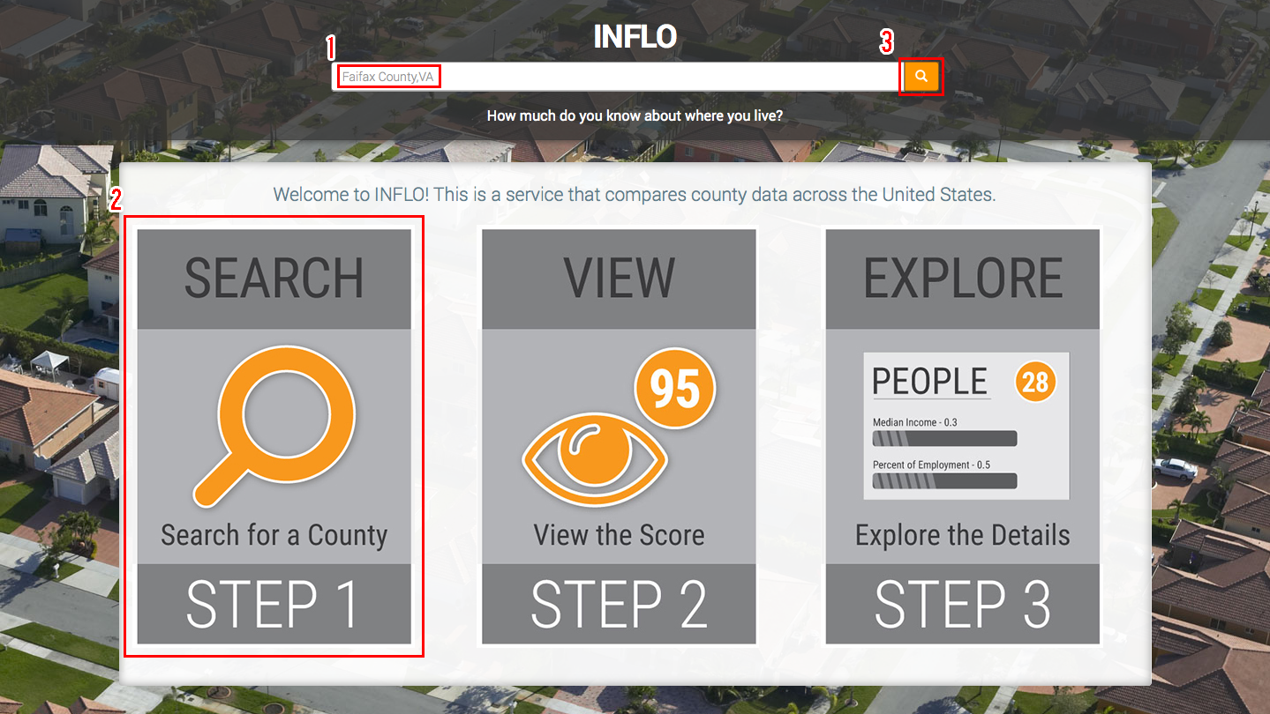

**INFLO Dashboard Screen (1rst Release):**

1. INFLO Score

* Score number should show context (Bad, Average, Good)
* Color orange association may prove confusing to user

1. Tile Score

* Score number should show context (Bad, Average, Good)
* Grey box distracts from header

1. Data Points

* Data points should show exact units (ppb, ppm, $0.00)
* Data points should not be separated by a dash
* Progress bar should not be animated

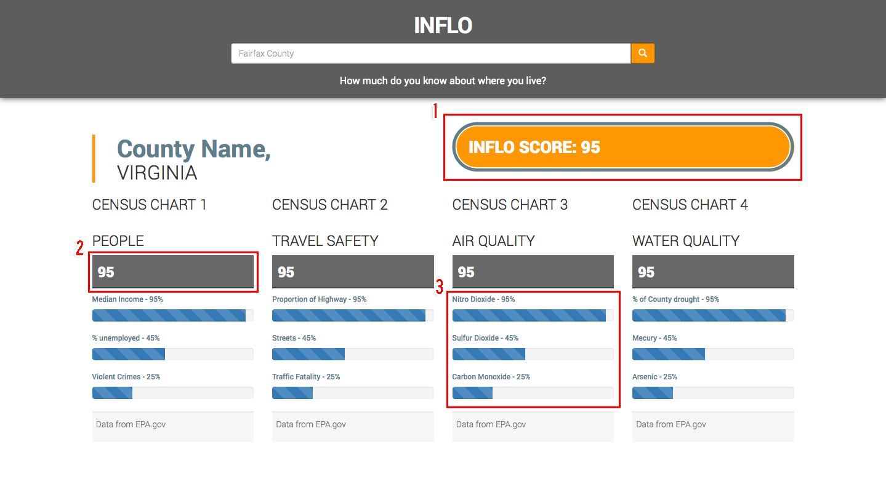

**INFLO Dashboard Screen Mobile View (1rst Release):**

* Tile content separation becomes difficult to see when viewed in mobile
* Error message text is not obvious to the user.
  + “No results found. Please check your spelling and try again.”

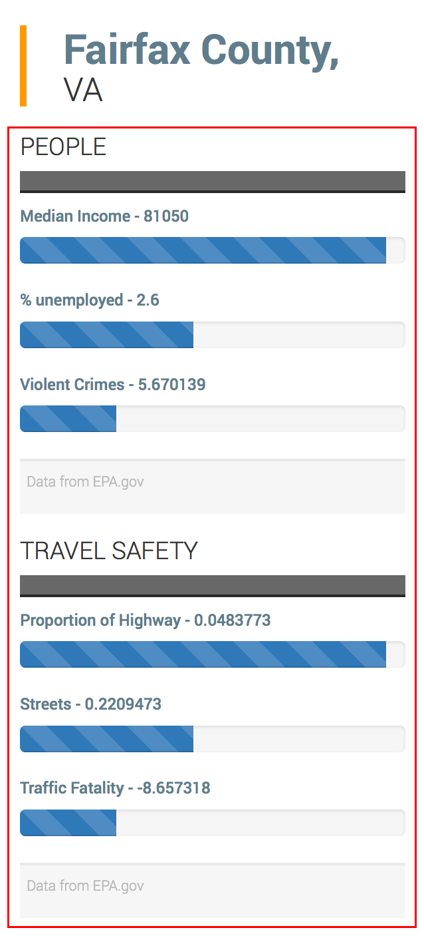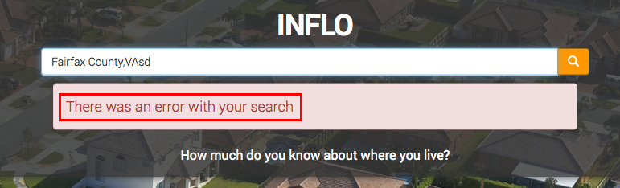

**Conclusion**

Searching for counties is the main user interaction and should be as simplistic as possible. Autocomplete as well as mistype leniency should be implemented to prevent errors. The user should also have access to a simple “Steps” example that gives an overview at a glance of what the application can be used for. No text should be raster as it will not be available for screen readers.

The dashboard should show easily identifiable ratings and provide understandable data points. All graphics and scores should have context and meaning to the user. Careful consideration regarding colors should be made when highlighting scores as to not display conflicting meanings.

The responsive mobile view tile data becomes difficult to separate when viewed on smaller devices. A more visible title or separator is needed.